The Baghdad Battery: A 2,000-Year-Old Power Cell Lost in Time
What if the key to a minor electrical revolution was not invented in the 18th century, but was instead sitting in the basement of a Baghdad Museum, forgotten for millennia? This is not science fiction; it is the compelling mystery of the Baghdad Battery.
Discovered in the 1930s near the metropolis of Ctesifonte, this peculiar artifact consists of a simple yet ingenious assembly: a terracotta vase, a copper cylinder, and an iron rod, all fixed together with asphalt. To the untrained eye, it might look like a religious relic or a simple scroll holder. But to the eyes of engineers and physicists, it bears an uncanny resemblance to a primitive galvanic cell.
The principle is elementary yet brilliant: two different metals with different electric potentials—copper and iron—submerged in an acidic electrolyte, such as vinegar or wine. This creates a chemical reaction capable of generating a continuous electric current. Modern replicas have proven it works, producing between 0.5 and 2 volts of electricity.
The implications are staggering. For what purpose did the Parthians or Sassanids, nearly two thousand years ago, need a small electric current? The most common speculation is electroplating—using the current to gild objects by depositing a layer of gold or silver onto them. Yet, this single, plausible explanation is often dismissed by mainstream archaeology, which prefers to label the jars as simple "containers for sacred texts," despite the acidic residue found inside.
This object is a quintessential Oopart—an "Out of Place Artifact." It represents knowledge that appears, is used for a specific, perhaps ritualistic purpose, and then vanishes from the historical record without a trace, never to be integrated into humanity's technological evolution.
The Baghdad Battery forces us to ask an uncomfortable question: how many other discoveries, which we conveniently dismiss as impossible, are waiting for us to shed our own mental boxes and see the past for what it might truly have been—a place of intermittent, brilliant, and lost genius?
The power was there, contained in a simple clay jar. The real question is, did we simply forget how to use it
José F. Revoredo

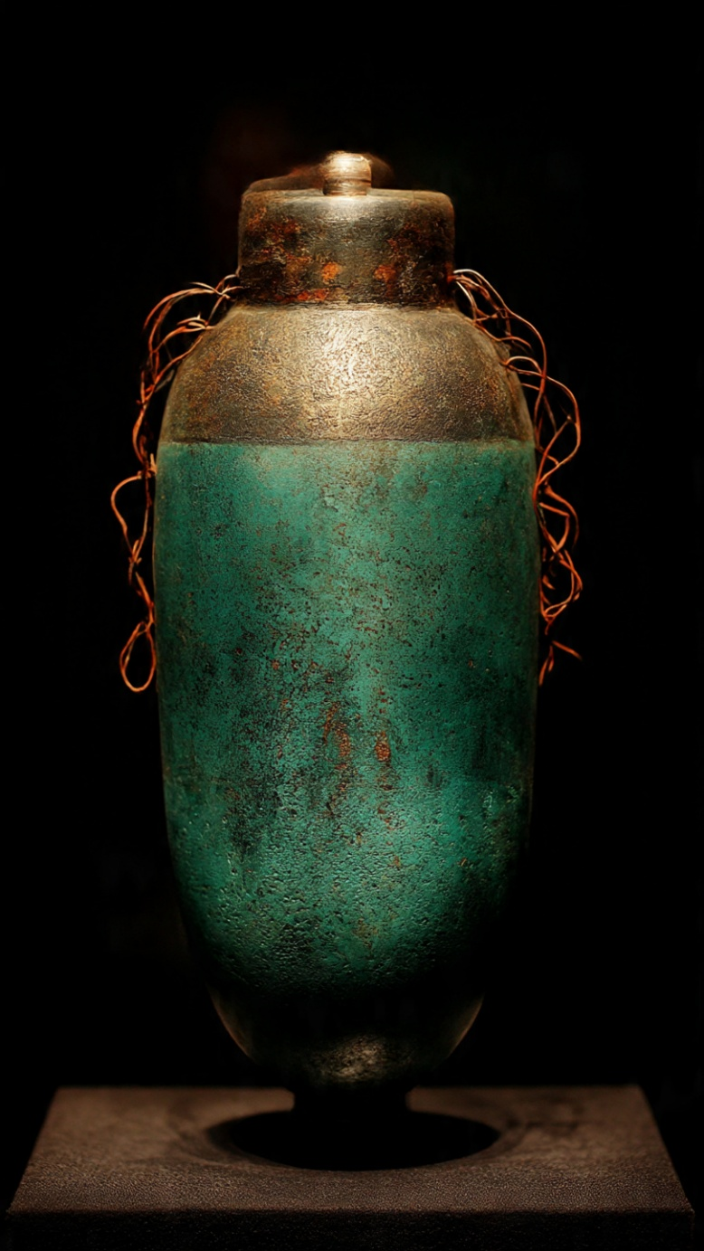
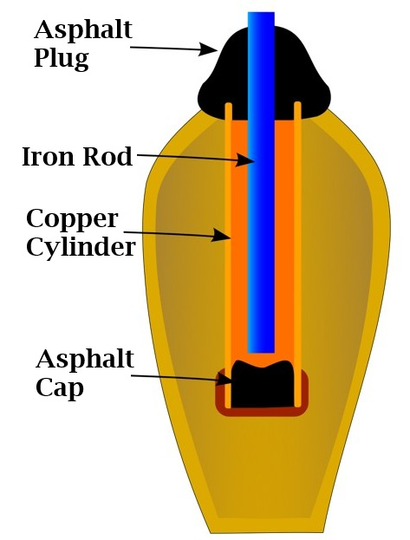
(Internal diagram of the battery by Chatsam - Own work, http://leradiofil.com/les_piles.htm, CC BY-SA 3.0, https://commons.wikimedia.org/w/index.php?curid=12790993)

